Three Tier using Docker

Step 1) Install docker compose

* sudo curl -L "<https://github.com/docker/compose/releases/latest/download/docker-compose-$(uname> -s)-$(uname -m)" -o /usr/local/bin/docker-compose
* sudo chmod +x /usr/local/bin/docker-compose
* verify docker compose: docker-compose version
* Use as docker-compose

Step 2) Create directory structure and add required files as below

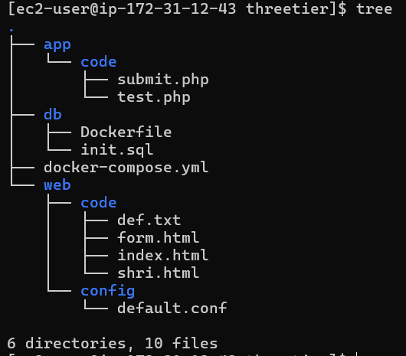

1. HTML files at ~/threetier/web/code/ for eg: form.html

<https://drive.google.com/file/d/1jzy6rWT0-bGSzYtgc-tEa9JFBJBwL8UR/view?usp=drive_link>

1. Configuration file at ~/threetier/web/config/ eg. default.conf

<https://drive.google.com/file/d/1EyDEbDA111HA0hGoEHrmHmbVcx_z60OG/view?usp=drive_link>

Changes are 🡪

# pass the PHP scripts to FastCGI server listening on 127.0.0.1:9000

location ~ \.php$ {

root /app;

fastcgi_pass app:9000;

fastcgi_index index.php;

fastcgi_param SCRIPT_FILENAME /app/$fastcgi_script_name;

include fastcgi_params;

}

1. Php files at ~/threetier/app/code/ eg : submit.php

<https://drive.google.com/file/d/1yJgQJuzLA9unClYRcWMNeM88yMCXnXz9/view?usp=drive_link>

1. Dockerfile for db at ~/threetier/db/

<https://drive.google.com/file/d/1xDkNFkQjONMX1CLUua3H_yokO38ldiAs/view?usp=drive_link>

1. Init.sql for db at ~/threetier/db/

<https://drive.google.com/file/d/1HhsSYNkD11I7fn05ufWC1WkNteaVSGSU/view?usp=drive_link>

1. Docker compose file at ~/threetier/ as docker-compose.yml

<https://drive.google.com/file/d/1KO1ZBMLDLgSqk44OAT37rKPXgsTF0ZS0/view?usp=drive_link>

Step 3) Execute docker compose file using docker-compose up -d

